W316R,W308R,W309R-How to assign a special IP address to a computer
Product line: wireless question category: function config

Q：Why we need set the static IP binding?
A：Sometimes we will want to assign a special IP address to special computer; you can achieve this by set static IP binding.
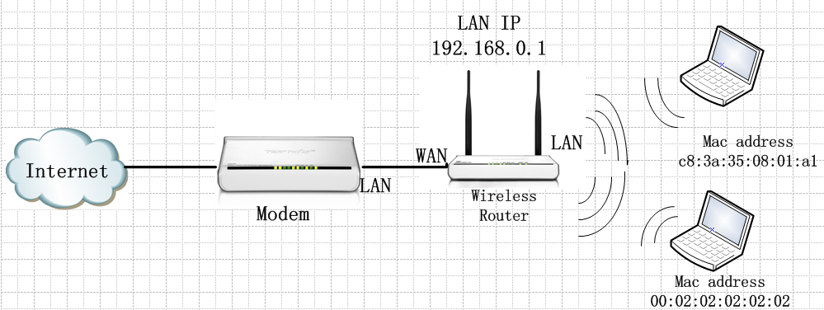
The Steps are as below:
1, Login to the home page of the router
2, click DHCP Server→DHCP client List on the top menu of the homepage. Then please add the MAC address to the list and click OK, then the computer with the MAC address will get the same IP address every time.
For example, we want the computer with MAC address C8:3a:35:08:01:a1 get the IP address 192.168.0.103, you can set the router following the picture as below.
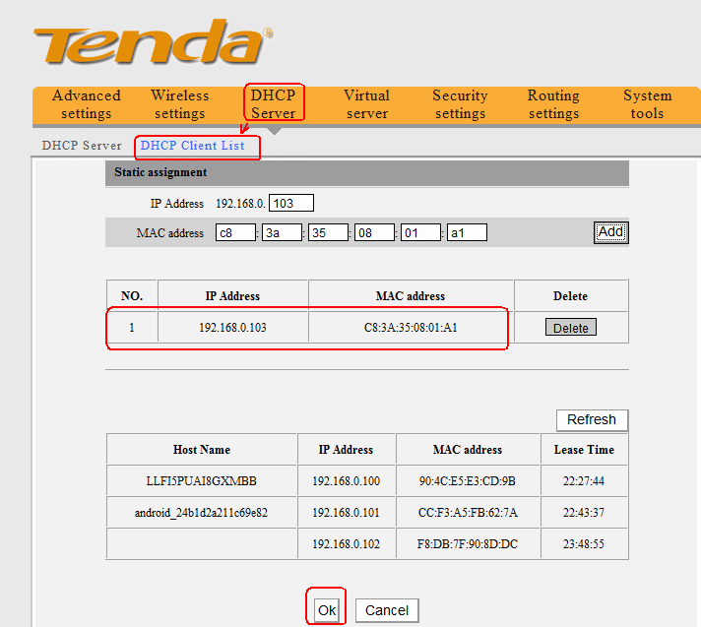
Then you can check the DHCP Client List as below.

